Lab 5 – Building A Movie Detail App With Navigation
1. Objective
In this lab, students will design and implement a simple Movie Detail App that demonstrates how to use Flutter’s navigation mechanisms (Navigator.push, MaterialPageRoute, or named routes) and basic UI composition.
The project reinforces the key ideas from Module 5 – Navigation & State Management.
2. Requirements
Create a two-screen Flutter application:
· Home Screen – displays a scrollable list of movies (poster, title, and rating).

· Movie Detail Screen – shows the selected movie’s information, including:
o Poster (Hero banner with gradient)
o Title and genres displayed as chips
o Overview text
o Action buttons (Favorite / Rate / Share)
o List of trailers

Technical Requirements
1. Navigation must use either
o Navigator.push + MaterialPageRoute, or
o Named routes (Navigator.pushNamed).
2. Pass a Movie object between screens.
3. Layout should be scrollable and responsive.
4. Use static sample data (no API calls).
5. The app must run correctly in DartPad and Android Studio / VS Code.
Optional Enhancements
· Implement a Favorite toggle that updates state.
· Add a simple search bar to filter movies.
· (Advanced) Experiment with a deep-link that opens a specific movie detail page.

3. Guided Steps
Step 1 – Project Setup
Create a new Flutter project (flutter create movie_app) or open DartPad Flutter.
Step 2 – Define Data Model
Create a Movie class with fields for id, title, posterUrl, overview, genres, rating, and a list of Trailers.
Add a sample_data.dart file containing 2–3 movie objects.
Step 3 – Build Home Screen
Use ListView.builder to display each movie card.
On tap → navigate to Movie Detail screen, passing the selected object.
Step 4 – Build Movie Detail Screen
Compose the UI progressively:
1. Blank Scaffold + AppBar
2. Hero Banner (Stack + Image.network + gradient)
3. Title & Genres (Column + Wrap + Chip)
4. Overview text with Padding
5. Row of IconButtons (Favorite, Rate, Share)
6. Trailer list using ListView.builder
Step 5 – Test and Polish
Run the app → check navigation works and UI scrolls smoothly.
Optionally add state management with setState() or ChangeNotifier.

4. Expected Result
When finished, the app should:
· Display a movie list on Home.
· Navigate to a detail page with poster, genres, overview, actions, and trailers.
· Return to Home using the Back button.
· Match the Demo Progress sequence in Figures 8.12 – 8.18 of Mastering Flutter 2025.
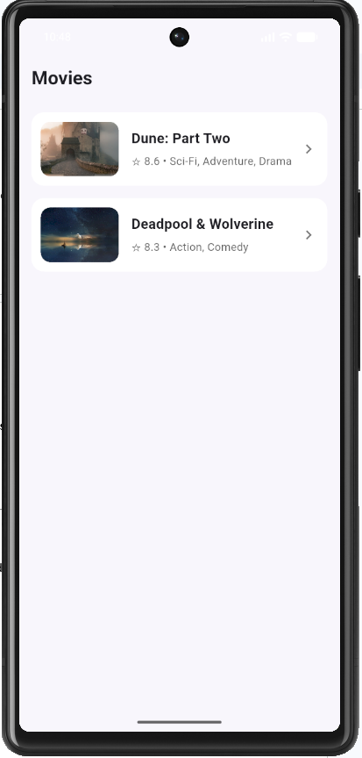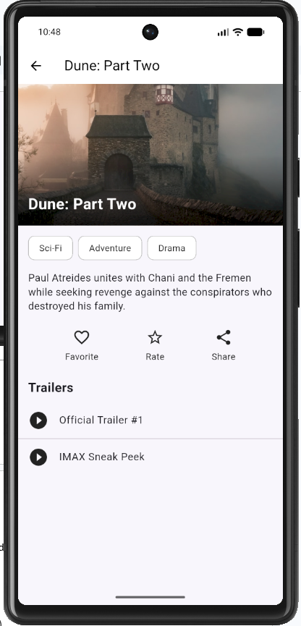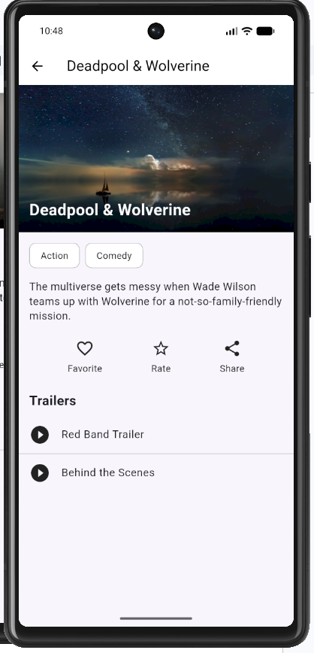
5. Submission
· Deliverable: Zipped Flutter project or DartPad share link.
· Evaluation Criteria:
o Correct navigation logic (30%)
o UI layout & design consistency (30%)
o Functionality & state handling (25%)
o Code clarity & comments (15%)

